

Exercises Report - Lab 7
LAB 7-Verifying Software Integrity (SHA256 & GPG)

Course: Cyber Security

Ljubljana, 28/5/2026 Vishnu Viswanath Thattrakkal
Student ID- 35250024

LAB 7 -Verifying Software Integrity (SHA256 & GPG)

INTRODUCTION
Downloading software or scripts from the internet can be risky because files may be modified, corrupted, or replaced with malicious versions. To reduce these risks, security tools such as SHA256 checksums and GPG digital signatures** are used.

SHA256 checksums help verify file integrity by confirming that a file has not been changed. However, checksums alone cannot guarantee authenticity because attackers may also replace the checksum value. GPG digital signatures provide an additional layer of security by verifying that the file comes from a trusted source and has not been tampered with.

In this lab, students will learn how to verify file integrity, use GPG for signing and verification, detect tampered files, and apply secure practices when downloading software or scripts.

LAB setup
You are provided with a single file: install.sh
This script simulates a basic software installation process. It will be used throughout the lab to practice verifying file integrity and authenticity before execution.

Task 1: Inspect the Script
cat install.sh

Before running any script, always inspect it. Using

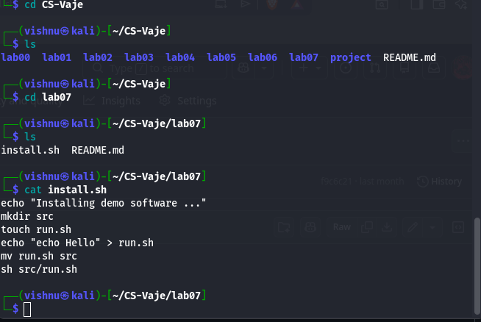
Image -1

This script allows you to see the content without opening it, like the nano command.
FIrst lets install the required packages: sudo apt install gnupg coreutils

Task 2: Generate SHA256 Checksum

To generate and save the SHA256 checksum of the file:sha256sum install.sh > install.sh.sha256

View the checksum: cat install.sh.sha256
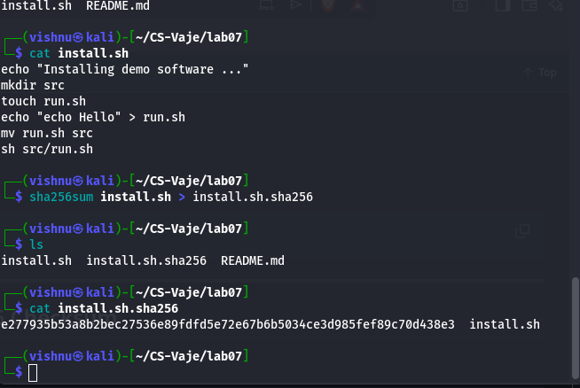

Image -2

Task 3: Verify File Integrity

Check if the file is unchanged: with script - sha256sum -c install.sh.sha256

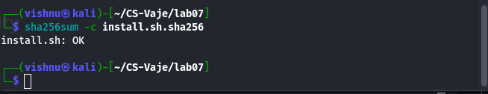
Image -3
Expected output: install.sh: OK

Task 4: Generate GPG Key Pair
Create your GPG key pair using: gpg --full-generate-key - (image -4)
Recommended Options
During setup, choose:
- Key type: RSA and RSA
- Key size: 4096 bits
- Expiration: Choose as preferred
- User ID: Enter your name and email address
- Passphrase: Set a strong password

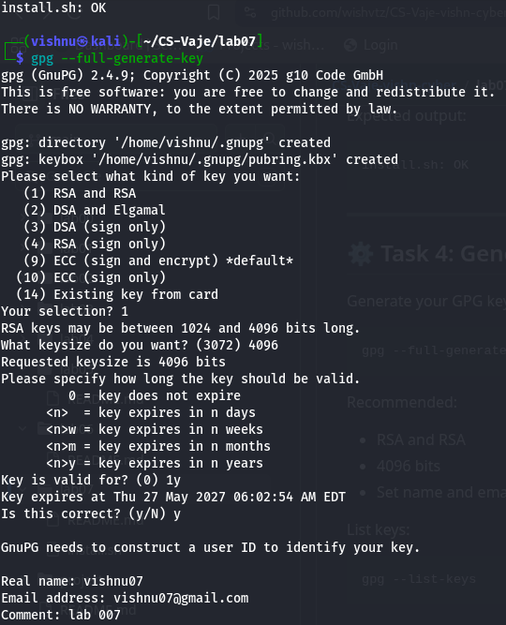
Image 4
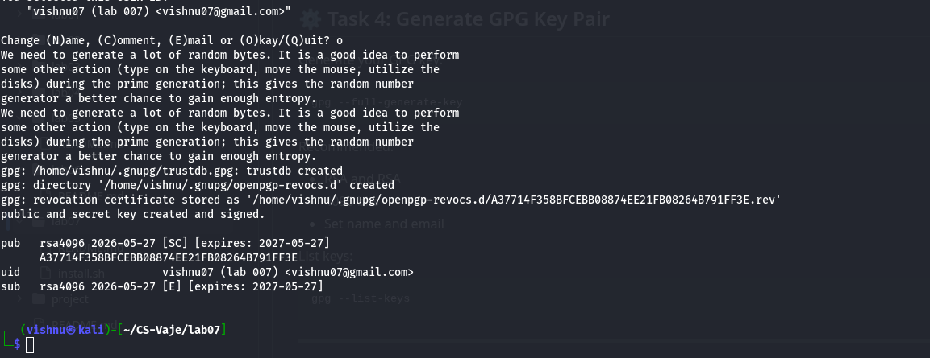
Image 5

The GPG key pair will be used to digitally sign files and verify authenticity.
List key -gpg --list-keys
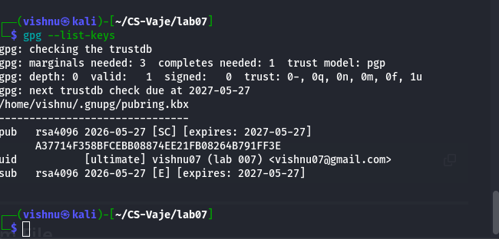
Image -6

Task 5: Sign the Checksum File

Sign the checksum file: gpg --detach-sign install.sh.sha256
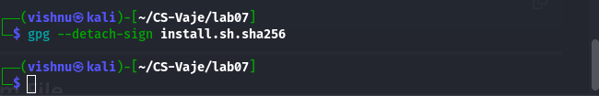
Image -7
This creates: install.sh.sha256.sig
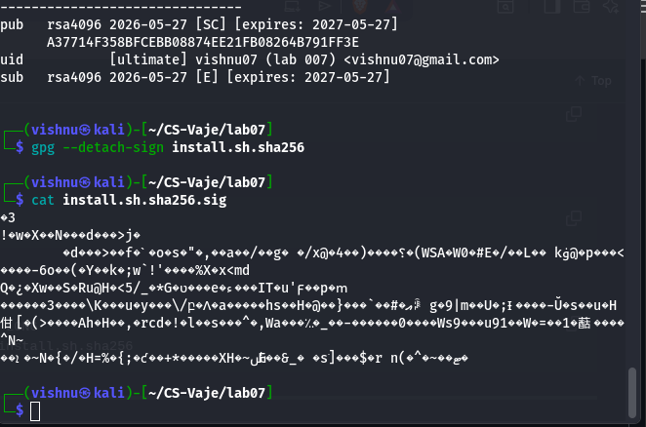
Image – 8
Note to use the same key:
- gpg --list-secret-keys --keyid-format LONG
- gpg --local-user KEYID --detach-sign install.sh.sha256

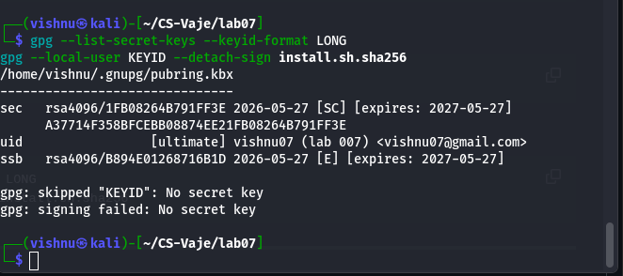
Image 9

Task 6: Verify the Signature
Verify that the checksum is authentic: gpg --verify install.sh.sha256.sig install.sh.sha256
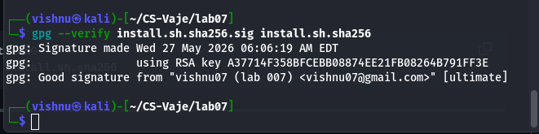
Image 10

Task 7: Simulate a Tampering Attack

Modify the script:
- echo "echo MALICIOUS CODE EXECUTED" >> install.sh
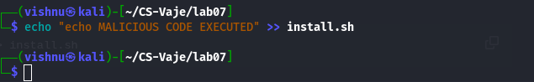
Image 11
Now verify again: sha256sum -c install.sh.sha256
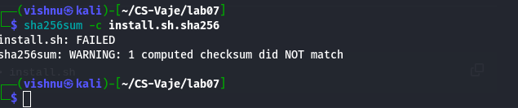
Image 12

Questions
- Why should you never execute scripts without inspection?
Because scripts can contain hidden malicious commands. If you run them without checking, they could:
- delete files
- steal data or credentials
- install malware or backdoors
- modify system settings silently
Always reviewing the content first helps prevent running harmful code.
- What does SHA256 guarantee?
SHA256 guarantees file integrity, meaning: The file has not been changed or corrupted since the checksum was created If even one character changes in the file, the SHA256 hash will be completely different.
- What does GPG guarantee?
GPG (GNU Privacy Guard) guarantees:

  - authenticity → the file really comes from the owner of the private key
  - integrity → the file has not been modified since it was signed
- Can SHA256 prove the author of a file?
SHA256 cannot prove the author of a file because it only checks whether the file matches a specific hash and does not include any identity verification.

- Why is signing the checksum important?
Signing the checksum is important because it prevents attackers from modifying both the file and the checksum without detection, since only the original creator can produce a valid signature.
- What happened after the script was modified?
After the script was modified, the SHA256 verification failed because the file’s content had changed, showing that the script had been tampered with.

